**Thruster Report**

|  |  |
| --- | --- |
| **Thruster Ratio:** | **1.200** |
| **Magnetic Field:** | **500 mT** |
| **Anode Power:** | **2603 W** |
| **Anode Current:** | **8.0 A** |
| **Anode Energy:** | **184346.8 J** |
| **Propellant:** | **Argon 0.499 mg/s** |

**Thruster Details: Nagoya magnet, LaB6 cathode, 1 mm orifice, copper anode, 80 mm internal diameter. CoM correction method: Anode Energy, Pre-offset 0.0 s, Post-offset 100.0 s, Cold-Gas thrust 0.1 mN**

|  |  |  |  |  |  |  |
| --- | --- | --- | --- | --- | --- | --- |
| Thrust | Thrust Eff. | ISP | Total DOF | Coverage Factor | Exp. Uncertainty | Std. Uncertainty |
| 26.7 mN | 27.4 % | 5446.5 sec | 23 | 2.08 | 3.1 mN | 1.5 mN |

**Thrust-Stand Uncertainty Components**

|  |  |  |  |  |  |  |  |
| --- | --- | --- | --- | --- | --- | --- | --- |
|  | Weights | Scale | Hysteresis | Repeatability | Noise | Offset | Drift |
| Value | 0.0 mN | 0.9 mN | 0.6 mN | 0.3 mN | 0.6 mN | 0.7 mN | 0.3 mN |
| DOF | 30 | 6 | 6 | 6 | 31 | 4 | 4 |

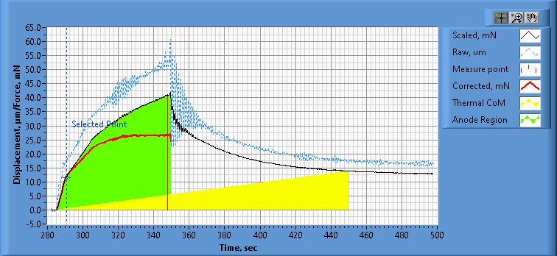

**Figure 1. Thrust Plot**

File Name: Philtech Data 2025.04.16_22.25.22.csv

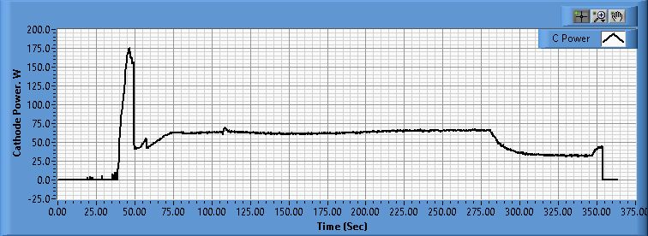

**Figure 2. Cathode Power Plot**

File Name: PSU C Data 2025.04.16_22.25.25.csv

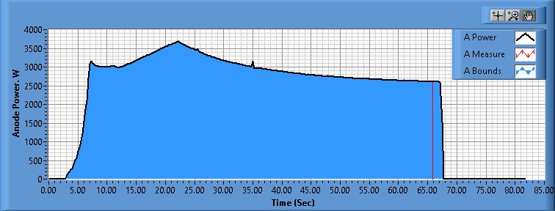

**Figure 3. Anode Power Plot**

File Name: PSU A Data 2025.04.16_22.30.04.csv

**Pre-Cal. Information**

File Name: Philtech Data 2025.04.10_11.46.21.csv

Start/Stop times (24 h): 11:46:28 11:50:13

Sensitivity: 1.53 um/mN

|  |  |  |  |
| --- | --- | --- | --- |
| Offset | Drift | Scale Factor | Scale Std.Dev |
| -0.151 mN | -0.033 mN/s | 0.656 | 1.436 mN |

Plateau values:

|  |  |  |  |  |  |  |  |  |  |  |
| --- | --- | --- | --- | --- | --- | --- | --- | --- | --- | --- |
| Weight 0 | Weight 1 | Weight 2 | Weight 3 | Weight 4 | Weight 5 | Weight 4 | Weight 3 | Weight 2 | Weight 1 | Weight 0 |
| -0.7 mN | 21.4 mN | 37.8 mN | 57.5 mN | 78.6 mN | 100.8 mN | 78.9 mN | 57.6 mN | 37.9 mN | 20.4 mN | -1.7 mN |

**Post-Cal. Information**

File Name: Philtech Data 2025.04.16_22.25.22.csv

Start/Stop times (24 h): 22:34:31 22:38:29

Sensitivity: 1.52 um/mN

|  |  |  |  |
| --- | --- | --- | --- |
| Offset | Drift | Scale Factor | Scale Std.Dev |
| -10.129 mN | -0.025 mN/s | 0.656 | 1.343 mN |

Plateau values:

|  |  |  |  |  |  |  |  |  |  |  |
| --- | --- | --- | --- | --- | --- | --- | --- | --- | --- | --- |
| Weight 0 | Weight 1 | Weight 2 | Weight 3 | Weight 4 | Weight 5 | Weight 4 | Weight 3 | Weight 2 | Weight 1 | Weight 0 |
| -0.0 mN | 20.5 mN | 37.3 mN | 58.1 mN | 78.6 mN | 100.8 mN | 78.4 mN | 58.7 mN | 37.3 mN | 19.9 mN | -0.3 mN |